TASK17:
Inter Service App
AIM: To enable inter-service communication where one microservice consumes another
service’s REST API and handles responses and failures gracefully.
ALGORITHM:
1. Start the program
2. Create Product Service (provider)
3. Create Order Service (consumer)
4. Implement REST API in Product Service
5. Store product data in memory
6. Implement Order Service API
7. Use axios/fetch to call Product Service
8. Receive response from Product Service
9. Process and store order data
10. Handle errors using try-catch
11. Send proper success/error response
12. Stop the program
FOLDER STRUCTURE:
inter-service-app/
│
├── product-service/
│ └── server.js
│
├── order-service/
│ └── server.js
PROGRAM:
PRODUCT-SERVICE:SERVER.JS:
const express = require("express");
const app = express();
let products = [
{ id: 1, name: "Laptop" },
{ id: 2, name: "Phone" }
];
app.get("/products", (req, res) => {
res.json(products);
});
app.listen(3001, () => {
console.log("Product Service → http://localhost:3001/products");
});
ORDER-SERVICE:SERVER.JS:
const express = require("express");
const axios = require("axios");
const app = express();
app.use(express.json());
let orders = [];
app.post("/orders", async (req, res) => {
try {
const response = await axios.get("http://localhost:3001/products");
const products = response.data;
const order = {
id: Date.now(),
products: products
};
orders.push(order);
res.json({
message: "Order created successfully",
order: order
});
} catch (error) {
res.status(500).json({
error: "Failed to fetch products from Product Service"
});
}
});
app.get("/orders", (req, res) => {
res.json(orders);
});
app.listen(3002, () => {
console.log("Order Service → http://localhost:3002/orders");
});
OUTPUT:
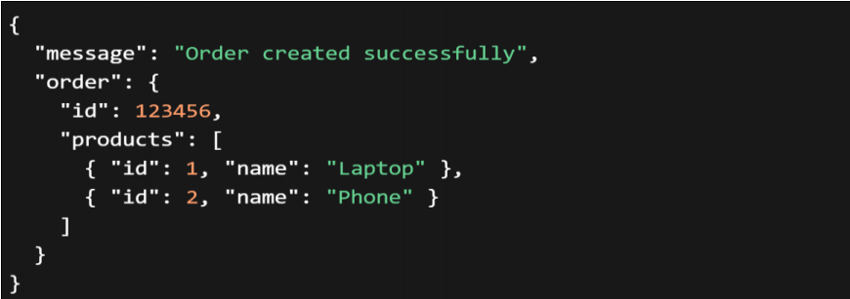


RESULT :
The Inter-service communication was successfully implemented using REST APIs, with proper handling of responses and failures between microservices.

